Object Detection in Medical Images

MACHINE LEARNING / COMPUTER VISION

*Proposal for an internship project at Clinical Graphics*

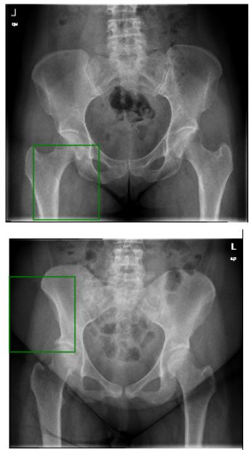

Clinical Graphics processes medical images to extract bones and perform motion simulations with them. For this purpose we use Active Shape Models (ASM), which provide a detailed segmentation of the bones. However, in order to run ASMs, they need to be initialized in a good starting position. This requires detection of the smallest region in the image data that contains the bone.

For this assignment, you will be implementing and evaluating a machine learning pipeline that can detect objects in medical images. This entails coming up with good features and creating training data. The main challenge is handling the wide range of real world images and volumes. Most notably, image data can be acquired in various ways (CT/MR scanners, X-ray tubes) which leads to different image data dimensionality (2D/3D) and different data distributions.

Added bonus: you will learn more about modern software engineering techniques such as reusable software design during the project.

|  |  |
| --- | --- |
| **Requirements**   * Must be implemented in Python [3] (making use of SciPy [1], sklearn [7], skimage [8] and IPython notebooks [2]) * Must have a reusable design [6] * Use the conda package manager [5] * Must be ready for use in production at end of project (w.r.t. efficiency and accuracy) * Code must be versioned in a GitHub repository [4] | **Agreements**   * Clinical Graphics will supervise and grade the project and report * Intellectual Property (IP) of the code will belong to Clinical Graphics   **Contact**  [**k.vangolen@clinicalgraphics.com**](mailto:k.vangolen@clinicalgraphics.com) |

**References**

[1] <http://www.scipy.org/>

[2] <http://ipython.org/>

[3] <https://www.python.org/>

[4] <http://www.github.com/>

[5] <http://conda.pydata.org/miniconda.html>

[6] <https://en.wikipedia.org/wiki/Reusability>

[7] [http://scikit-learn.org/](http://scikit-learn.org/stable/#)

[8] <http://scikit-image.org/>